**Air Quality Index Level Prediction Using Random Forest**

**Algorithm on Cluster Computing of Spark**

# **WaliullahArshi Y.Amartya K. Hemanth**

# School of Computer Science and Engineering

# Vellore Institute of Technology

# Vellore, INDIA

# **Swarnalatha.P**

# Associate Professor

# School of Computer Science and Engineering

# Vellore Institute of Technology

# Vellore, INDIA

**Abstract**—As particulate materials recognizable all around can cause a couple of sorts of respiratory and cardiovascular diseases; the air quality information foreseeing draws in increasingly more consideration. Realizing this data ahead of time is imperative to shield human from medical issues. With the improvement of PC innovation, the information we can gather is progressively ending up fine-grained. Most imperative of all, they should be examined progressively. Notwithstanding, existing techniques couldn't fulfill the need of continuous investigation. In this paper, we envision air quality reliant on a Spark utilization of unpredictable woods computation. Introductory, a flowed self-assertive woods figuring is completed using Spark dependent on adaptable appropriated dataset and shared variable. By then, we produce an air quality figure exhibit using the parallelized arbitrary timberland calculation. The proposed strategy is assessed with genuine meteorology information got from Beijing. The examination results show that the proposed procedure is fast in predicting center component of PM2.5. Besides, the results moreover exhibit the reasonability and versatility of our system when oversee tremendous data.

# I. INTRODUCTION

Traffic advancement and industrialization improvement cause the development of air tainting. With the disintegrating of air quality, darkness wonder is winding up progressively certified and has been a universally issue, especially in metropolitans of making countries. There are diverse sorts of toxins in the urban air, for instance, PM10, PM2.5, SO2, and so forth. Among all of these pollutions, PM2.5, as it might be taken in into lungs clearly and even be separated into blood, has a high centrality with lung illness and cardiovascular issue. In order to shield individuals from damage of air pollution, anticipating the Air Quality Index (AQI) values has expanded much thought. There are two essential ways predicting AQI measurement of a zone. One is using the conventional dispersing model, for instance, Gaussian peak dissipating model Community Multiscale Air Quality Model and so on. These models can get modestly accurate result, yet it is difficult to pick the application conditions consequently many key parameters are troublesome to set.

data mining frameworks. In tree-based troupe portrayal computations are used to build PM2.5 focus level prescient model. Be that as it may, the normal estimation of PM2.5 of a year in can't mirror the continuous air quality data of an area. Gaussian procedure relapse is utilized in to foresee air quality esteem. They send 51 gadgets to gauge PM2.5 and utilize one-month information to assess their deduction display. In paper, numerous information sources manure used to induce AQI level. The model needs 5 minutes to deduce all the air quality benefit of Beijing. It tends to be unmistakably realized that if there is more information, additional time will be required. With the improvement of Internet of things and huge information innovation, plenteous information is accessible on the Internet and it is winding up increasingly more ordinary utilizing information digging techniques for air quality estimating. Conventional information mining calculations are not reasonable to tackle air quality expectation with enormous informational index.

Distinctive machines.The developing procedure is quickened through the exchanging of calculation from specialist hubs to ace hub on account of little informational index. At that point, arbitrary woodland calculation on Spark is utilized to assemble characterization demonstrate. In the wake of preprocessing, the genuine meteorology informational collection of Beijing of an entire year is utilized to assess the effectiveness. Finally, the versatility of the proposed AQI level expectation strategy is tried when manage huge information. This paper is organized as follows. Section II overviews the classification and regression tree and traditional random forest algorithm. Our distributed parallel implementation of random forest algorithm is given in section III. Section IV displays the experiment and results. Section V concludes the paper.

# II. PRINCIPLE OF THE ALGORITHMS

To execute the disseminated arbitrary backwoods calculation on Spark, it is vital to know the rule of sporadic Random woods count, which depends on gathering and backslide tree (CART). Along these lines, in this portion, the essential idea of CART count is cleared up at first and after that the quick and dirty utilization methodology of subjective woodlands estimation is appeared.A. CART algorithm

decision treecalculation is an emphasis procedure by choosing ideal part credit so as to get a decent grouping result for the subset of data. All around, there are generally three phases in structure a decision tree, i.e., decision of part quality, improvement of the tree and tree pruning. Among them, the extent of the qualities' contaminating impact is the most basic development. In CART count, Gini list is used to check the contamination of attributes. Moreover, it is portrayed as

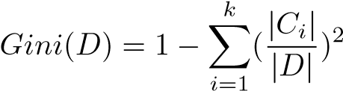*.* (1)

In the above condition, D speaks to any example informational collection, is the likelihood that a tuple in D has a place with class Ci. The total is figured over k classes. For any characteristic A in preparing information D, the dataset D is parceled into D1 and D2 as

*D*1 = {(*x,y*) ∈ *D*|*A*(*x*) = *a*}*,D*2 = *D* − *D*1*.* (2)

Given the partitioning in (2), the Gini index is

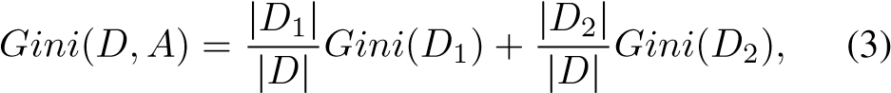

whereGini (D, A) suggests the sullying of enlightening accumulation D under the state of A = a. The more noteworthy the Gini record regard, the higher the pollution of the enlightening list. The subset data that gives the base Gini list a motivating force for that attribute is picked as its part subset. Tree pruning, which is used to swear off overfitting issue, must be taken a shot at the created tree. Generally talking, there are two ordinary systems for tree pruning: pre-pruning and post-pruning. The pruning system in CART count involves two phases. In the first place, the tree is pruned by cost multifaceted nature from the base inward center to the root center, and a movement of subtrees will be created as {T0,T1,••• ,Tn}. By then, the perfect subtree is looked over all the subtrees through cross-endorsement. The cost multifaceted nature measure can be created as

*Rα*(*T*) = *R*(*T*)+ *α*|*T*|*,* (4)

where R(T) is the estimation of hub polluting influence, |T| is the quantity of terminal hubs in the tree and α( 0) is a punishment forced on every hub. α is utilized to change the connection between integrity of fit and tree multifaceted nature. At the point when α is littler, the relating ideal subtree is bigger. For any interior hub.*t* in *T*0, when considering *t* as a single node tree, the cost complexity of *t* is

*Rα*(*t*) = *R*(*t*)+ *α.* (5)

When considering *t* as a root node, the cost complexity of tree *Tt*is

*Rα*(*Tt*) = *R*(*Tt*)+ *α*|*Tt*|*,* (6)

let*Rα*(*t*) = *Rα*(*Tt*), which means *Rα*(*t*) and *Rα*(*Tt*) have a similar cost multifaceted nature, however the tree with single hub t is less difficult than Tt. The decrease level of cost unpredictability, LF(t), can be defined as

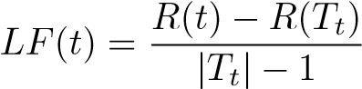*.* (7)

## Each internal hub is computed with Eq.7 and a progression of LF(t) will be obtained, the hub with the smallest LF(t) is selected as pruning hub. The pruned tree is littler and more obvious, and it can likewise improve the generalization ability on arranging new tuples.

## B. Random Forest

Irregular Forest is a tree-based gathering learning technique and has been commonly used in precedent affirmation, AI and data mining. It incorporates the mix of a couple of models to deal with a single figure issue. Last desire is gained through throwing a tally by different self-ruling figures made by different classifiers. Self-assertive forest is an amassing of many CART trees that are not influenced by each other when it is created. Tests that used to set up a singular CART are aimlessly browsed the arrangement dataset with substitution, by the day's end, some tuples could be picked more than once and others may never be used in any trees. Instead of the decision of tuples, features are picked discretionarily without substitution.

# III. DISTRIBUTED IMPLEMENTATION OF RANDOM

FOREST AND AQI LEVEL PREDICTION STEPS

## A. Random Forest Algorithm Implementation on Spark

There are numerous difficulties in actualizing irregular woodland calculation on conveyed structures. One of the greatest difficulties is to prepare heaps of choice trees over information put away in various machines. Other than that information synchronization just as information consistency must be mulled over. As CART in arbitrary timberland is completely developed, the tree is mind boggling and includes monstrous calculation, particularly in the current huge information time. The in-memory calculation model of Spark can dodge circle I/O in dealing with center yield information

created by emphasis process. Sparkle enormously quickens the calculation procedure that huge information includes.

To run applications on Spark, three sections, i.e., ace hub, bunch chief and specialist hub, are included. Ace hub speaks with laborer hubs through group supervisor. Driver program on ace hub is accountable for information parcel, hub measurements processing and agent’s data gathering. The usefulness of group director is designating assets crosswise over applications. Agents of laborer hubs are forms that run calculation and store information for the application. In irregular woods calculation, in the wake of stacking information from neighborhood plate, the ace hub performs information segment and hub insights processing and after that sends these data to the agents of specialist hubs. Specialist hubs run calculations, for example, tuple inspecting with substitution, quality testing without substitution and Gini file esteem computation. In the choice tree developing procedure, an edge θ is set. On the off chance that the rate that traits testing information estimate represented the all-out information measure is not exactly θ, the calculation procedure is transferred from agent of specialists to driver of ace. Exactness is the percentage that the tuples are correctly predicted by the classifier, and it is a standout amongst the most widely recognized measure. Review implies the percentage of positive tuples that are correctly marked as positive. Be that as it may, exactness is the percentage that what predicted as positives are truly positive tuples.To a certain degree, the greater the estimation of measures, the better the execution of classifier.

|  |  |  |  |  |  |  |  |  |  |  |  |  |  |  |  |  |  |  |  |  |  |  |  |  |  |  |  |  |  |  |  |  |  |
| --- | --- | --- | --- | --- | --- | --- | --- | --- | --- | --- | --- | --- | --- | --- | --- | --- | --- | --- | --- | --- | --- | --- | --- | --- | --- | --- | --- | --- | --- | --- | --- | --- | --- |
| Table I: Detailed information of our data set   |  |  |  |  |  |  |  |  |  |  |  | | --- | --- | --- | --- | --- | --- | --- | --- | --- | --- | --- | | Attribute | station id | longitude | latitude | time | temperature | weather | wind speed | pressure | humidity | PM2*.*5 | | Data Type | string | double | double | data time | int | int | float | int | int | string | | Example | 001005 | 39.742768 | 116.136045 | 2/8/2013 9:00:00 PM | -5 | 2 | 5.8 | 1031 | 46 | U | |

Both memory size and number of centers can be changed by application needs. The centers that are utilized in the program are from 2 to 8. Step 4: The driver hub processes the insights of information segment and after that sends this data to laborers through group chief. Agents on laborers are sitting tight for calculation. Step 5: Training and anticipating utilizing our usage of irregular woodland calculation on Spark. Step 6: Evaluation of the algorithm, such as precision, recall and so on.

**literature survey :**

So this paper talks about a situation in China Over the past decade, major cities in China have suffered from severe air pollution, which is also known as smog. Despite lay considerations that smog might pose risks for psychopathology, it remains unknown whether it is only linked to affective psychopathology or to a broader range of symptomologies.Moreover, whether individual differences in emotion regulation, a transdiagnostic risk factor for psychopathology, would influence the magnitude of pollution-induced symptoms is not well understood.Moreover, reappraisal is negatively associated with smog-induced elevations in psychopathological symptoms only when participants rely heavily on suppression. We discuss the implications of this investigation for both intervention efforts and future work on the contextual factors surrounding the deployment of emotion regulation strategies.

They used the regression models to estimate the association between reductions in and changes in life expectancy. The association was stronger in more urban and densely populated counties. As the primary analysis. Data they constructed and analyzed three data sets to estimate the association between changes in life expectancy and changes and to investigate whether the association previously reported when the data on the same. The report the results of our primary analysis, which estimated the cross-sectional relationship between life expectancy and PM2.5, and between changes in life expectancy and changes.Level greater than the current were not in compliance. On average, decreased at a rate lower than observed analyzed. Variable Mean Life Expectancy Data on air pollution and life expectancy from that show that recent declines to relatively low levels continue to prolong life expectancy. These benefits are largest among the most urban and densely populated counties. Here, a decrease was associated with an increase in life expectancy of 0.35 for 545 counties for the period.

This paper states that the Community Multiscale Air Quality model is a state-of-the-science air quality model that simulates the emission, transformation, transport and fate of the many different air pollutant species that comprise particulate matter, including dust. The CMAQ model has several enhancements over the previous version of the model for estimating the emission and transport of dust, including the ability to track the specific elemental constituents of dust and have the model-derived concentrations of those elements participate in chemistry. The latest version of the model also includes a parameterization to estimate emissions of dust due to wind action. The CMAQ modeling system was used to simulate for the world, and the model estimates were evaluated against daily surface based measurements from several air quality networks. The CMAQ modeling system generally did well replicating the observed soil concentrations in many parts; however the model consistently overestimated the observed soil concentrations. The performance of the individual trace metals was generally good at the rural network sites. For the urban site had comparatively better performance throughout the year than the other trace metals, which were consistently overestimated, including very large overestimations. An underestimation of nighttime mixing in the urban areas appears to contribute to the overestimation of trace metals. Removing the anthropogenic fugitive dust emissions and the effects of wind-blown dust lowered the model soil concentrations.Concentrations were still often overestimated, suggesting that there are other sources of errors in the modeling system that contribute to the overestimation of soil components. Efforts are underway to improve both the nighttime mixing in urban areas and the spatial and temporal distribution of dust related emissions sources in the emissions inventory.

It supports a rich set of higher-level tools including Spark SQL for SQL and structured data processing, MLlib for machine learning, for graph processing, and Spark Streaming. Scala and Java users can include Spark in their projects using its Maven coordinates and in the future Python users can also install Spark from PyPI. If you'd like to build Spark from source, visit Building Spark. R. The Spark cluster mode overview explains the key concepts in running on a cluster. Spark can run both by itself, or over several existing cluster managers. Deploy Spark on top of HadoopNextGen. Deploy Spark on top of Kubernetes. A series of training camps at UC Berkeley that featured talks and exercises about Spark, Spark Streaming, Mesos, and more.

Random forests are a combination of tree predictors such that each tree depends on the values of a random vector sampled independently and with the same distribution for all trees in the forest. The generalization error for forests converges a.s. to a limit as the number of trees in the forest becomes large. The generalization error of a forest of tree classifiers depends on the strength of the individual trees in the forest and the correlation between them. Using a random selection of features to split each node yields error rates that compare favorably to Adaboost (Y. Freund & R. Schapire, Machine Learning: Proceedings of the Thirteenth International conference, ***, 148–156), but are more robust with respect to noise. Internal estimates monitor error, strength, and correlation and these are used to show the response to increasing the number of features used in the splitting. Internal estimates are also used to measure variable importance. These ideas are also applicable to regression.

# IV. EXPERIMENT AND RESULTS

|  |  |  |  |  |  |  |  |
| --- | --- | --- | --- | --- | --- | --- | --- |
| Truth |  | Predictions | | |  |  | |
| G | M | US | U | VU&H |
| G | 1088 | 157 | 13 | 3 | 2 | 0.8614 | Recall |
| M | 169 | 755 | 237 | 27 | 11 | 0.6297 |
| US | 10 | 98 | 966 | 278 | 26 | 0.7012 |
| U | 10 | 38 | 72 | 1584 | 184 | 0.8390 |
| VU&H | 5 | 1 | 3 | 59 | 964 | 0.9341 |
|  | 0.8487 | 0.7197 | 0.7483 | 0.8112 | 0.8121 | 0.7925 | |
|  | Precision | | |  |

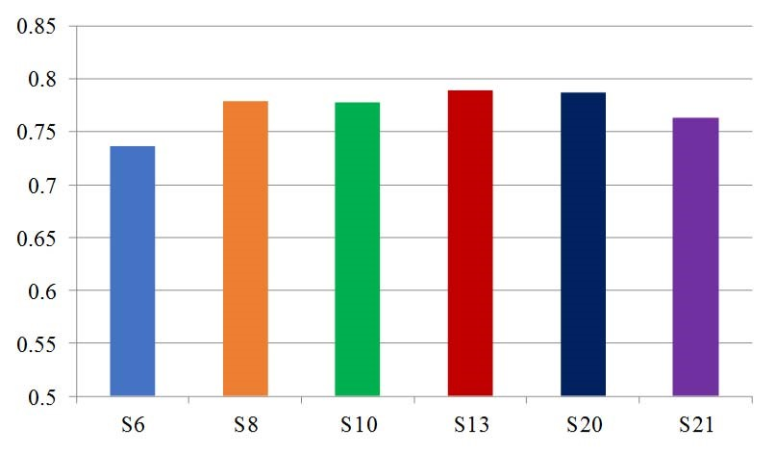

Figure 2: Accuracy of other tests

1. *Accuracy:*

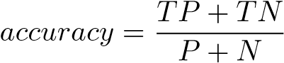 (8)

1. *Recall:*

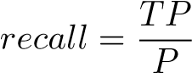 (9)

1. *Precision:*

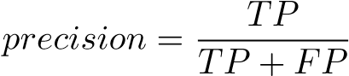 (10)

Exactness is the percentage that the tuples are correctly predicted by the classifier, and it is a standout amongst the most widely recognized measure. Review implies the percentage of positive tuples that are correctly marked as positive. In any case, exactness is the percentage that what predicted as positives are truly positive tuples. To a certain degree, the greater the estimation of measures, the better the execution of classifier.Table III: Execution time comparison among different methods

Time(s) Data size

D*2 D*4 D*8 D*16 D*32

Method

### standalone-random forest 10.1 23.3 53.6 142.1 357.4 Spark-random forest 24.2 32.1 50.4 96.8 192.9

Table III demonstrates the execution time examination of arbitrary timberland calculation between independent usage and Spark usage. As should be obvious from the table, when the informational collection is moderately little, customary arbitrary timberland calculation takes less time than the appropriated usage of irregular backwoods calculation on Spark. Be that as it may, with the expansion of the informational index, our usage of irregular timberland calculation dependent on Spark performs well than conventional arbitrary woods calculation. This plainly shows when we are looked with huge informational collection, it is fundamentally required by utilizing Spark to quicken the examination procedure.

**TEST CASES :**

**CASE :1 :-**Test result of CART analysis :

a)

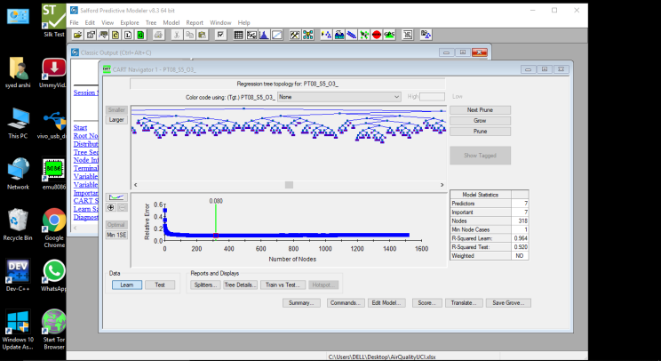

b) Mean analysis :

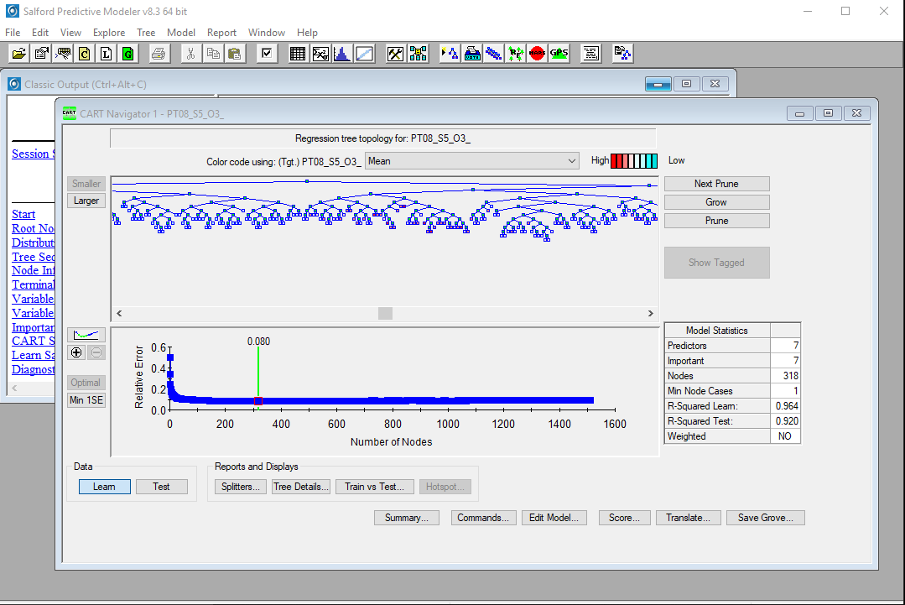

c) Median analysis

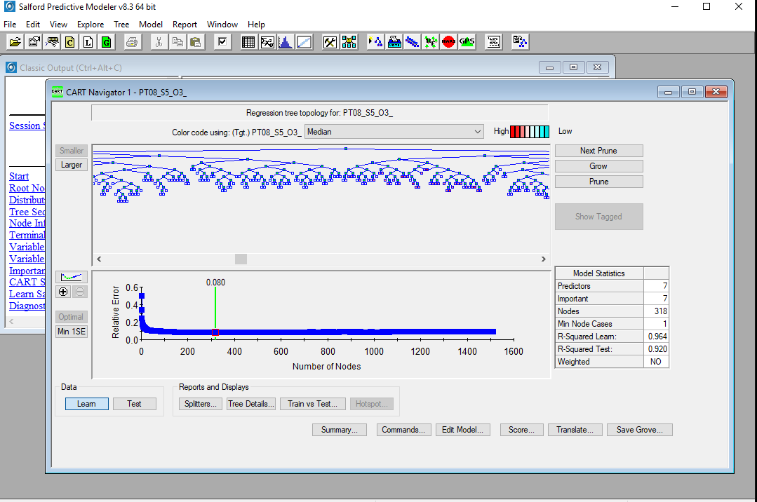

d) Tree map :

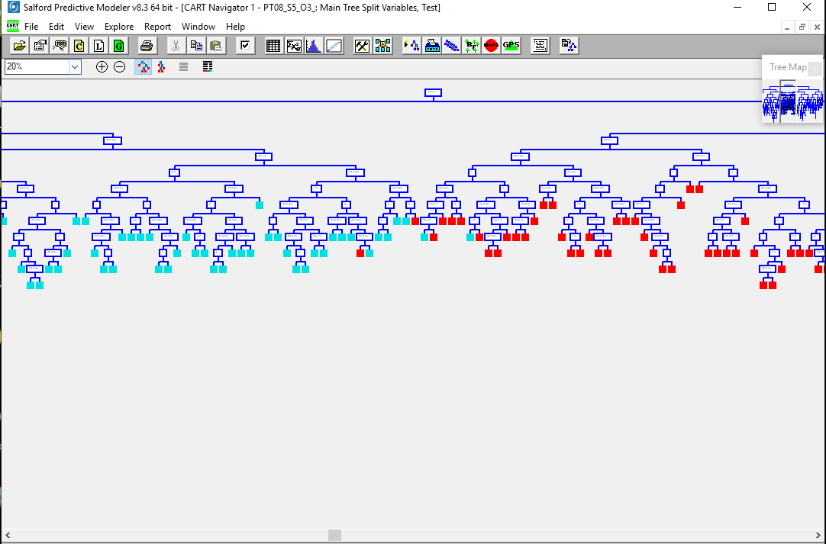

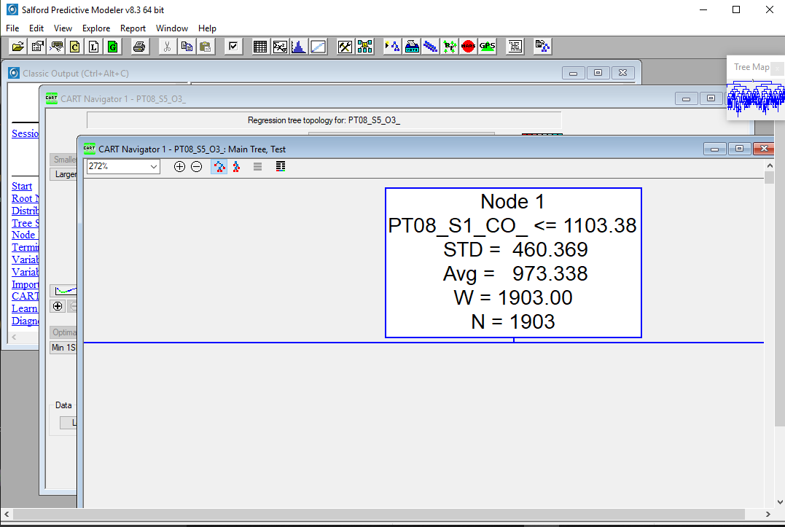

MAIN TREE :

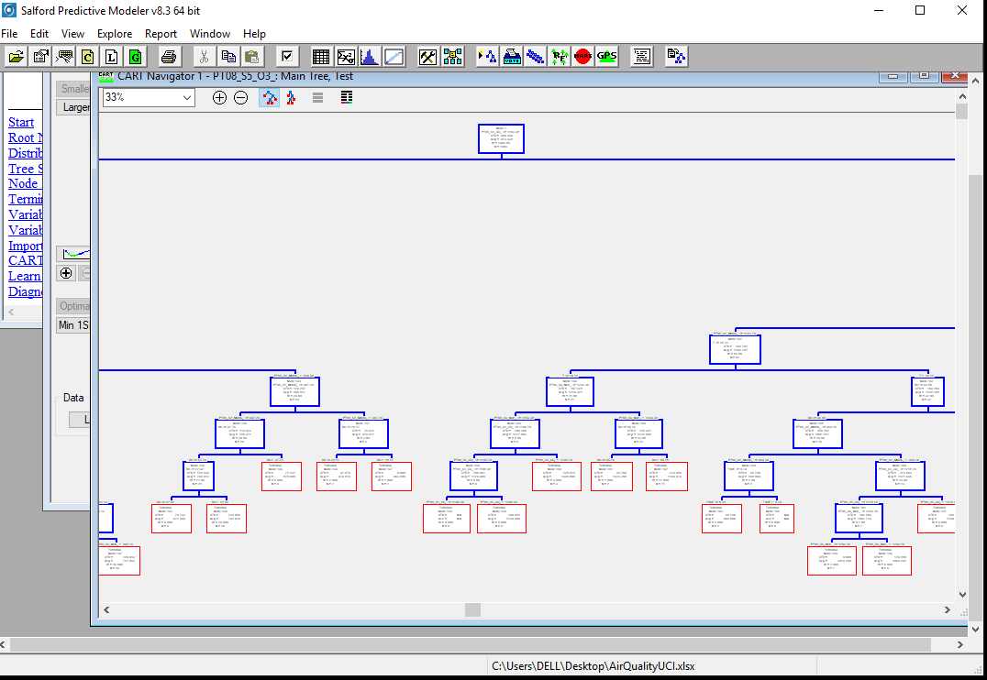

Train vs test result

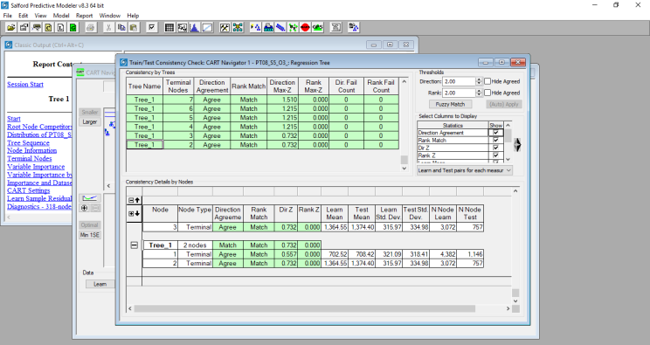

Test summary

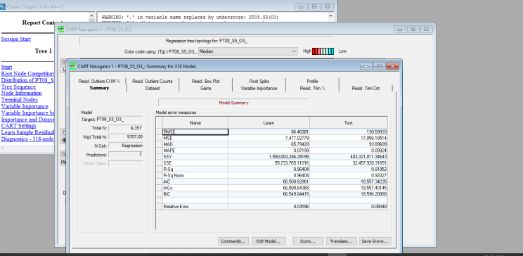

Command

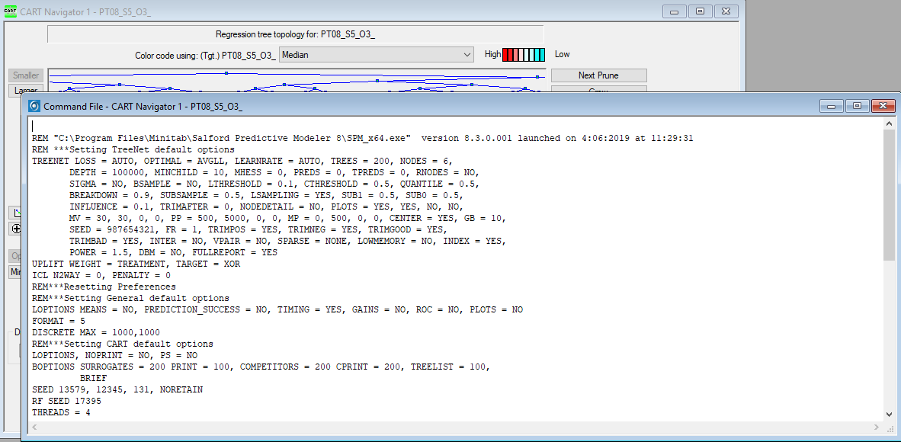

**TEST CASE 2 :-**Random forest

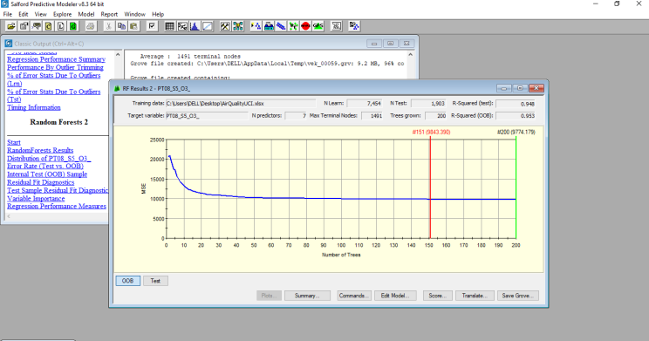

**TEST CASE 3 :-**MARS ANALYSIS

Learn and test result

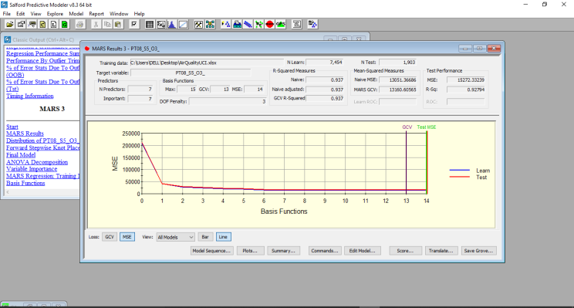

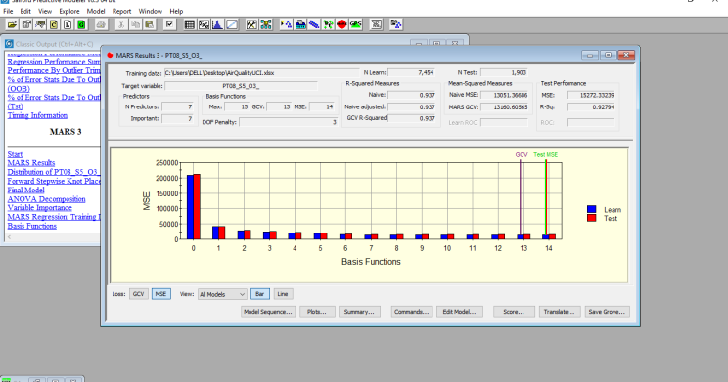

Module sequence :

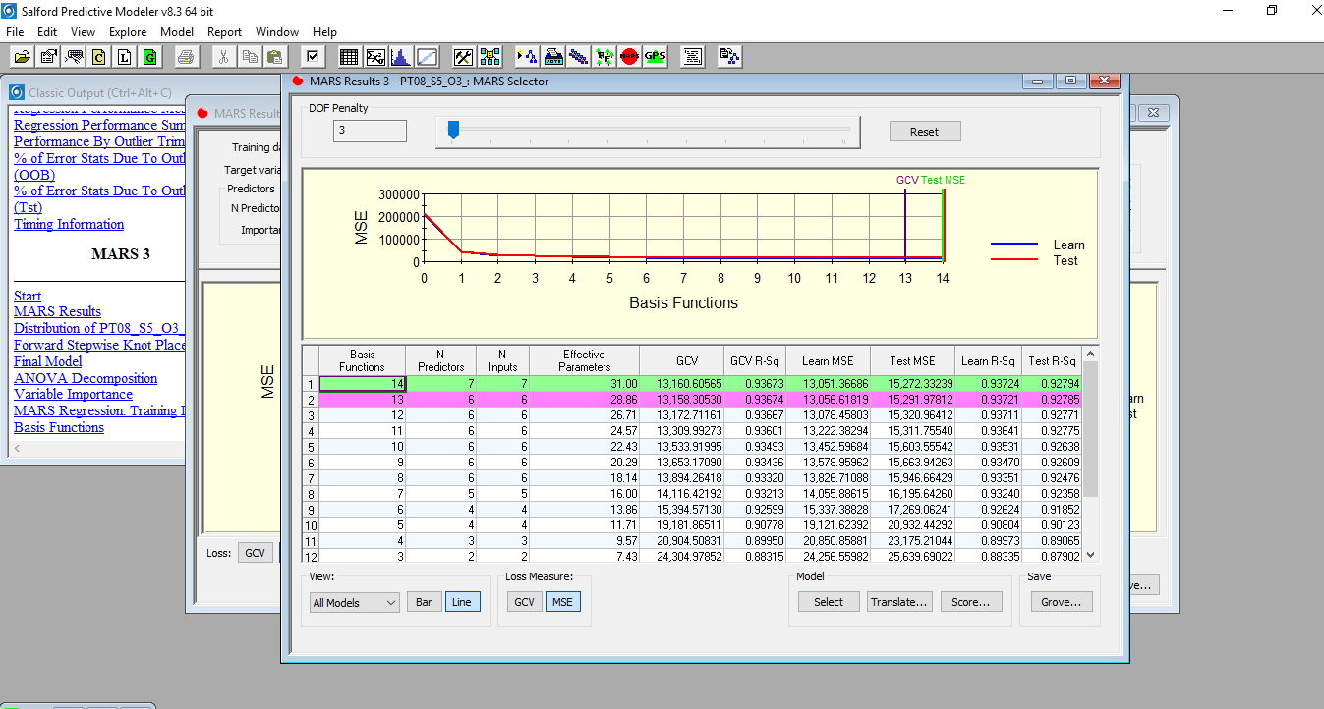

# V. CONCLUSION

In this paper, we proposed a fast fine-grained AQI level conjecture procedure subject to the execution of sporadic woods computation on Spark. By using the bundle figuring of Apache Spark, we executed a dispersed sporadic timberland count. A point of confinement θ was set in the program. Right when the model data size to the hard and fast data gauge is smaller than this breaking point, the estimation technique is traded from specialist to driver. As the framework needs extra time than count, this edge θ can stimulate decision tree advancement. To survey execution of our proposed procedure, we coordinated a couple of examinations on authentic meteorological data of Beijing. The results have exhibited that our proposed technique can get high regard both in Precision and Recall. By then time capability and flexibility of our proposed methodology have furthermore been shown while overseeing colossal enlightening list.

## ACKNOWLEDGMENT

The work displayed in this paper was bolstered to a limited extent by our colleague.

## REFERENCES

1. U. Franck, S. Odeh, A. Wiedensohler, B. Wehner, and O. Herbarth, “The effect of particle size on cardiovascular disorders - the smaller the worse,” *Science of the Total Environment*, vol. 409, no. 20, pp. 4217–4221, 2011.
2. C. A. Pope III, M. Ezzati, and D. W. Dockery, “Fineparticulate air pollution and life expectancy in the united states,” *New England Journal of Medicine*, vol. 360, no. 4, pp. 376–386, 2009.
3. B. Ristic, A. Gunatilaka, and R. Gailis, “Achievable accuracy in parameter estimation of a gaussian plume dispersion model,” in *Statistical Signal Processing (SSP), 2014 IEEE Workshop on*. IEEE, 2014, pp. 209–212.
4. K. Appel, G. Pouliot, H. Simon, G. Sarwar, H. Pye, S. Napelenok, F. Akhtar, and S. Roselle, “Evaluation of dust and trace metal estimates from the Community Multiscale Air Quality (CMAQ) model version 5.0,” *Geoscientific Model Development*, vol. 6, no. 4, pp. 883–899, 2013.
5. Y. Zhao and Y. A. Hasan, “Fine particulate matter concentration level prediction by using tree-based ensemble classification algorithms,” *International Journal of Advanced Computer Science and Applications (IJACSA)*, vol. 4, no. 5, 2013.
6. Y. Cheng, X. Li, Z. Li, S. Jiang, and X. Jiang, “FineGrained Air Quality Monitoring Based on Gaussian Process Regression,” in *Neural Information Processing*. Springer, 2014, pp. 126–134.
7. Y. Zheng, F. Liu, and H.-P. Hsieh, “U-Air: When urban air quality inference meets big data,” in *Proceedings of the 19th ACM SIGKDD international conference on Knowledge discovery and data mining*. ACM, 2013, pp. 1436–1444.
8. Apache hadoop. Online; accessed 23-March-2015. [Online]. Available: http://hadoop.apache.org/
9. Apache spark–lightening-fast cluster computing. Apache. Online; accessed 23-March-2015. [Online]. Available: http://spark.apache.org/
10. J. Chen, H. Chen, G. Zheng, J. Z. Pan, H. Wu, and N. Zhang, “Big smog meets web science: smog disaster analysis based on social media and device data on the web,” in *Proceedings of the companion publication of the 23rd international conference on World wide web companion*. International World Wide Web Conferences Steering Committee, 2014, pp. 505– 510.
11. L. Breiman, “Random forests,” *Machine learning*, vol. 45, no. 1, pp. 5–32, 2001.
12. D. Steinberg and P. Colla, “CART: classification and regression trees,” *The top ten algorithms in data mining*, vol. 9, p. 179, 2009.
13. J. Han, M. Kamber, and J. Pei, *Data mining, southeast asiaedition: Concepts and techniques*. Morgan kaufmann, 2006.
14. Z.-H. Zhou, *Ensemble methods: foundations and algorithms*. CRC Press, 2012.
15. J. Manyika, M. Chui, B. Brown, J. Bughin, R. Dobbs, C. Roxburgh, A. H. Byers, and M. G. Institute, “Big data: The next frontier for innovation, competition, and productivity,” 2011.
16. Y. Zheng, X. Chen, Q. Jin, Y. Chen, X. Qu, X. Liu, E. Chang, W.-Y. Ma, Y. Rui, and W. Sun, “A cloud-based knowledge discovery system for monitoring fine-grained air quality,” MSR-TR-2014-40, Tech. Rep., 2014.